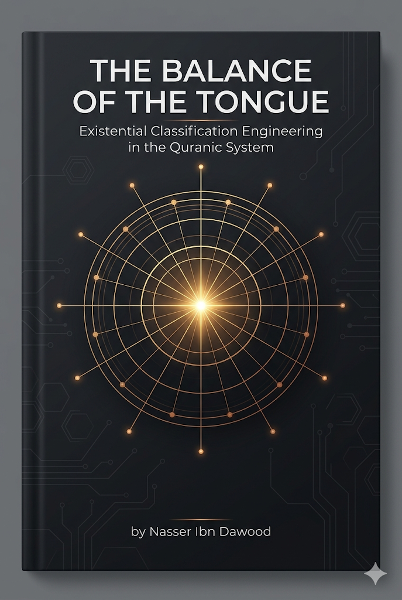
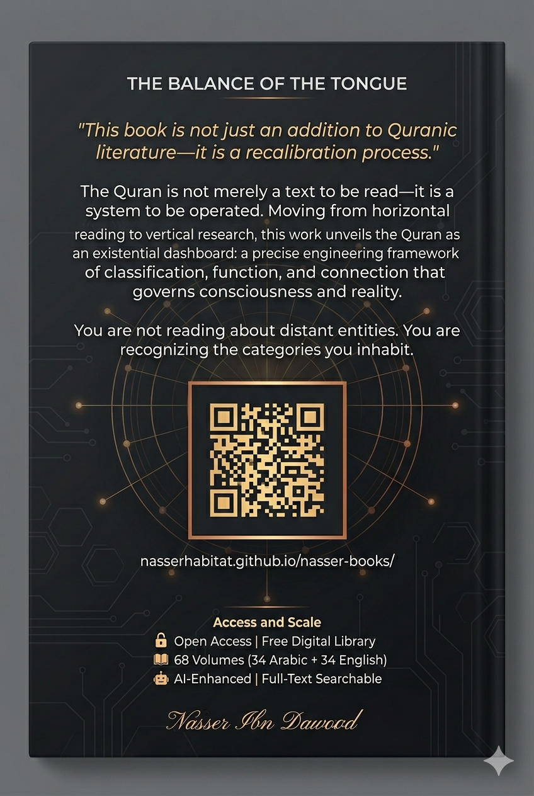

# The Balance of the Tongue: Existential Classification Engineering in the Quranic System

## A Condensed Conceptual Guide for the International Reader

---

# Preface: From Narrative to Structure

This book is not another addition to Quranic literature. It is a **"recalibration process"** of the guidance system through linguistic engineering and vertical research.

The major dilemma facing the Muslim mind was never the absence of the text—it was the **"absence of the balance"** . Doctrinal and institutional interpretations turned the cosmic laws and existential software of the Quran into mere historical rituals or rigid linguistic templates.

This work moves from **"surface reading"** to **"structural depth."** We do not read words as linguistic vocabulary but as **"classificatory codes."**

---

# What Changes When We Read the Quran as an Operating System?

Traditional reading asks: *What does the text say?*

This approach asks: *How does the text work?*
Traditional Reading | Operating System (OS) Reading
Words have "Meanings" | Words have "Functions"
Focus is on lexical semantics and dictionary definitions (Static data). | Focus is on the Utility/Output; what the word triggers or executes in the system (Dynamic trigger).
Concepts have "Definitions" | Concepts have "Roles within a Network"
Concepts are defined by their boundaries and what they exclude (Isolation). | Concepts are Nodes; defined by their connectivity and how they interface with other modules (Integration).
Verses are "Sentences" | Verses are "Operational Units"
Verses are treated as grammatical constructs or narrative sequences (Linguistic flow). | Verses are Runtime Commands or logic gates that dictate the flow of energy, behavior, and existence (Executable protocols).

The goal is not to provide ready-made answers but to enable the reader to:
- Observe patterns
- Track relationships
- Test hypotheses

---

# The Core Methodology: Vertical Research

**What is Vertical Research?**

Instead of reading the Quran sequentially from beginning to end (horizontal reading), vertical research locks onto a single word and tracks its path across the entire text.

**Frequency as "Specific Gravity"**

In engineering, specific gravity determines a material's load-bearing capacity. In the Quranic tongue, frequency determines a word's **"operational pressure"** :

- **High-frequency words** (Allah, said, those who): The **"load-bearing pillars"** of the system. Any flaw in understanding them collapses the entire interpretive structure.

- **Low-frequency words**: **"Specialized codes"** that operate in very specific conditions to calibrate precise situations.

**The Golden Rule:** *"The higher the statistical frequency of a word, the lower the probability of metaphorical interpretation, and the higher the certainty of its systemic function."*

---

# The Three-Layer Classification System

## Layer One: The Sovereignty Layer (The Source)

**The Beautiful Names are not "attributes of praise"—they are "governing laws."**

|
Functional Category | Divine Names | Operational Role (Systemic Perspective)
Infrastructure | Al-Khaliq, Al-Bari', Al-Musawwir | Conceptual Engineering: Strategic estimation, material execution, and final aesthetic formation of entities.
Power & Sustenance | Ar-Razzaq, Al-Wahhab, Al-Muqit | Energy Distribution: Pumping vital resources and "bio-fuel" to ensure systemic continuity and prevent collapse.
Control & Monitoring | As-Sami', Al-Basir, Ar-Raqib, Al-Muhaymin | Universal Sensing: Real-time data acquisition and comprehensive oversight of all internal and external variables.
Maintenance & Recovery | Al-Ghafur, At-Tawwab, Al-'Afuww, Al-Jabbar | System Correction: Identifying functional gaps, repairing errors (deviations), and restoring the entity to its "factory settings."
System Stability | Al-Hafiz, Al-Qayyum, Al-Quddus | Structural Integrity: Maintaining cohesion, preventing entropy (chaos), and ensuring the purity of the system's operation.
Governance & Law | Al-Hakam, Al-'Adl, Al-Malik | Central Processing & Authority: Establishing the universal constants, laws, and final judicial resolutions that govern the system.

## Layer Two: The Active Entities Layer (The Processors)

**The Threefold Classification (Ins, Jinn, Bashar)**

These are not mythical creatures but **"levels of operation"** within a single existential system:
**The Linguistic Insight (Amr ↔ Imra'ah)**
Term | Root | Functional Definition
Bashar | B-Sh-R | The Biological Hardware: The visible, physical state of the entity. It represents the "external interface" and the material shell subject to entropy and physical laws.
Ins | A-N-S | The Social Interface: The state of connectivity and intimacy. It represents the transition from a "biological unit" to a "societal node" capable of interaction and companionship.
Jinn | J-N-N | The Backend Processes: The latent, concealed state. It represents the "hidden scripts" and background energies that influence the visible behavior without being seen.
Term | Functional Essence | Operational Definition
Dhakar (Male) | The Emitter | The Active Vector: Designed to project, transmit energy, and initiate influence outward within the system.
Untha (Female) | The Receiver/Container | The Nurturing Matrix: Designed to absorb, contain, and process input to manifest it into a new fruit or organized structure.
Rajul (Man) | Operational Integrity | The Executive State: A non-biological functional rank defined by "standing" (Qiyam)—the capacity to uphold responsibility, maintain steadfastness, and execute command.
Imra’ah (Woman) | Reflective Pairing | The Mirroring State: The entity that pairs with a source, internalizes the command (Amr), and reflects it into a tangible, lived reality.

The Quranic link between *amr* (command) and *imra'ah* (woman) reveals:
- **Amr** (أمر): The "broadcast" energy seeking a space to settle
- **Imra'ah** (مرأة): The "space" that absorbs that energy and transforms it into stable reality

This is why the Quran does not call a female "imra'ah" unless she is in a functional pairing relationship—she becomes the executor of "operating commands" within the system.

## Layer Three: The Operating Environment (The Field)

**Ad-Duha (The Morning Brightness) is not a time—it is a "phase of disclosure"**
Concept | Traditional View | Engineering View (OS Perspective)
Ad-Duha | Morning time / Early daylight | Full Manifestation Phase: The state where data/meaning emerges from latency into a high-resolution, observable output.
Al-Layl (Night) | Darkness / Nighttime | The Containment System: A shielded "closed-loop" environment designed to protect internal processes and facilitate structural incubation away from external interference.
Saja (Covering) | Idle stillness / Nightly calm | The Charging & Stabilization State: A phase of internal equilibrium and potential energy accumulation, ensuring system stability before the next deployment cycle.

**The Operational Trinity of Surah Ad-Duha:**

1. **Protection Protocol (Al-Yateem - The Orphan):** The disconnected entity. Command: *"Do not oppress"* —do not crush what is disconnected; allow it to stretch and rebuild.

2. **Flow Protocol (As-Sa'il - The Questioner):** The entity seeking connection. Command: *"Do not repel"* —keep communication channels open to ensure data flow.

3. **Update Protocol (Fa Haddith - Then Proclaim):** The final output. Command: **"Update"** —rebroadcast the blessing to ensure the system does not calcify or die in silence.

---

# The Statistical Weight of the Top Ten Words

|
Word | Approx. Frequency | Functional Description (OS Perspective)
Allah | 2,699 | Central Processing Unit (CPU) & Environment: The absolute operator and the supreme container of all sub-processes and laws.
Alladhina | 1,080 | Logic Connector / Bus: A dynamic link that clusters entities based on their functional attributes or metadata.
Qala | 529 | Interaction Engine: The protocol of communication; confirms the system is interactive and operates on "request/response" logic.
Kana | 512 | State Persistence: The stability program; confirms that laws and attributes are continuous states, not temporary glitches.
Ard (Earth) | 461 | Execution Interface / Lab: The physical hardware and operational field where the "Succession" (Khilafa) operations are tested.
Kull (Every) | 372 | Global Constant: Asserts the universality of engineering laws; ensures there are no "exception errors" in the divine sunan.
Yawm (Day) | 349 | Cycle Measurement: The temporal unit used to track transformations, outputs, and the final "system audit."
Sama’ (Sky) | 310 | Control Source / Uplink: The higher layer of the system architecture from which commands and vital energy (Wahy/Rain) descend.
Amanu | 258 | Security Protocol (Encryption): The internal code that stabilizes the human processor and protects the system from cognitive dissonance.
Nas (People) | 241 | Target Biological Mass: The fundamental end-user and the collective entity targeted for systemic reform and guidance.
---

# Units of Measurement: Structural and Kinetic Dysfunction

The Quranic system measures entity efficiency based on three criteria:

## 1. Al-Yateem (The Orphan) - Measuring Disconnection (Y-T-M)

**Definition:** Any entity (person, idea, project) cut off from its operational support or growth source.

**The Dysfunction:** A state of "informational amputation"—the entity finds itself isolated from the total system.

**Treatment (Iwa' - Providing Shelter):** Providing a "connection space" that reintegrates this isolated entity into the system's "server," ensuring continued data flow and protection.

## 2. Al-Faqeer (The Needy) - Measuring Structural Gap (F-Q-R)

**Definition:** A "break" in the entity's vertebrae—a gap in the backbone.

**The Dysfunction:** The entity suffers from "structural fracture"; its connecting vertebrae (cognitive or material) are disconnected, preventing it from standing or performing sovereign functions.

**Treatment (Ighna' - Enriching):** A "functional splinting" that fills the gaps (vertebrae) to restore the entity to "uprightness" and load-bearing capacity.

## 3. Al-Miskin (The Destitute) - Measuring Kinetic Inertia (S-K-N)

**Definition:** Possessing the structure but lacking activation energy.

**The Dysfunction:** The entity has "tools" but lacks "drive"—energy has been contained and suppressed until movement stopped.

**Treatment (Tahreek - Mobilization):** Revitalization to bring the entity out of "calcification" into beneficial "flow" within society.

**Comparison Table:**

|
Criterion | Al-Faqeer (Structural Gap) | Al-Miskin (Kinetic Stagnation)
Root Meaning | F-Q-R: A fracture or missing link in the vertebrae (the system's backbone). | S-K-N: A state of "Sukun" or total cessation of movement/flow.
Nature of Dysfunction | Structural Failure: A critical lack of basic tools, resources, or "connecting nodes" required to function. | Kinetic Failure: The tools exist, but the "flow" is deactivated. The system is trapped in a static state.
Visual/Operational State | "Broken" Architecture: The entity is physically or structurally unable to bear the load of life. | "Dormant" System: The engine is present, but the ignition is off; there is no output despite having the hardware.
Systemic Treatment | Reconnection: Repairing the "vertebrae" by providing the missing structural links and core assets. | Reactivation: Breaking the "Sakan" (stagnation) to restore the dynamic flow and kinetic energy.
---

# The Five Operating Commandments

## First: The Criterion of Statistical Weight

**Rule:** The most frequently repeated word in the Quran is the "sovereign element" in the system.

**Application:** Do not exhaust your energy on rare words before deconstructing the "software pillars" (Allah, Lord, All-Knowing, those who, believed). Repetition is a "warning siren" telling you: *here lies the system's engine.*

## Second: From "Meaning" to "Function"

**Rule:** Do not ask "What does this word mean?" Ask "What is its function and position in the system's network?"

**Application:** Meaning changes with historical context, but "linguistic function" is constant. Words in the "Tongue Engineering" are software codes performing specific tasks in building existential classification.

## Third: The Sovereignty of Connecting Letters (Network Logic)

**Rule:** "Letters" (min, fi, ila, alladhina) are the "data vectors" in the Quran.

**Application:** Neglecting the study of connectors turns the text into scattered particles. The engineering researcher understands that "network logic" hides in these letters that determine flow directions between entities.

## Fourth: Classification Instead of Interpretation (Dashboard)

**Rule:** The Quran is a "dashboard," not a book of historical stories.

**Application:** If you face a "breakdown" in your reality or consciousness, search for the "class" you have assumed. Have you activated the "spider" algorithm, weakening your structure? Or risen to the "bee" station, making your giving beneficial?

## Fifth: Integration with the 68 Volumes

**Rule:** This book is the "key"; the library is the "laboratory."

**Application:** Whenever a concept resists you, return to its dedicated volume in the digital library, where we have performed "vertical dissection" of every atomic letter, moving from "speculation" to "software certainty."

---

# The Global Knowledge Manifesto

## I. Knowledge as a Universal Right

Knowledge is a universal right. The author firmly believes that wisdom should not be locked behind paywalls or language barriers.

- **Global Access Policy:** All books in this library are available for free in multiple digital formats (PDF, HTML, DOCX, TXT).
- **The Digital Library:** As of early 2026, the collection hosts 68 volumes (34 in Arabic and 34 in English), fully optimized for AI-assisted research and digital archiving.
- **Official Platforms:**
- Main Website: nasserhabitat.github.io/nasser-books/
- GitHub: nasserhabitat/nasser-books

## II. Translator's Note: The Bridge of Meaning

This English edition is a condensed conceptual adaptation. It is not a word-for-word translation, but rather an **"extraction of essence."** It presents the core philosophical framework in accessible English, omitting the exhaustive linguistic debates and classical references found in the original Arabic text.

**For the academic researcher:** The original Arabic version remains the primary source for comprehensive linguistic analysis, detailed exegesis (Tafsir), and the complete bibliography.

---

# The Covenant of the Operator

1. **The Rule of Frequency:** Every word in the Quran has its own frequency; repetition determines the amplitude of its wave in existence.

2. **The Rule of Reflection (Imra'ah):** The human being (whether male or female) is the mirror reflecting the divine "command." The stability of your "system" depends on your discipline with "commands."

3. **The Rule of Connection:** Classification is not a fixed destiny—it is a "connection state." You can always "update" your class by moving from one rank to a higher one through activating the "stations of the prophets."

---

# Final Word

> *"This book is not the end of research. It is the instruction manual that opens the doors of the 68 volumes in my library, enabling the reader to engineer their life according to the balance set by the Creator of the heavens and the earth."*

**Naser Ibn Dawoud**
**Casablanca, Morocco**
**February 2026**

